**Institutional Sponsorship**

We want to sell high so we have to look for buyers in the market above old highs Look at the HTF to give us a framework to see if we have institutional sponsorship

**Institutional Sponsorship: How To Identify** It In **Setups**

*A* Institutional Sponsorship In Long Setups:

Higher Time Frame Price Displacement - Reversals, Expansion or Return To Fair Value. Intermediate Term Imbalance In Price - Move To Discount or Sell Side Liquidity Run.

Short Term Buy Liquidity Above The Market - Ideal For Pairing Long Exits To Sell To. Time Of Day Influence ie. London Open Low Of Day or New York Low Formation.

Institutional Sponsorship In Short Setups:

Higher Time Frame Price Displacement - Reversals, Expansion or Return To Fair Value. Intermediate Term Imbalance In Price - Move To Premium or Buy Side Liquidity Run.



Short Term Sell Liquidity Below The Market - Ideal For Pairing Short Exits To Buy From.

Time Of Day Influence ie. London Open High Of Day or New York High Formation.

Everything in this teaching will be focused on long setups.

For our setups to be high probability we have to have institutional sponsorship

Institutional sponsorship is the willingness to protect an underlying price swing that has high probability of holding, its the impact of big equity traders and they come in to fund to run towards the side we anticipate it running to

Its a repeating thing, theres characteristics. Especially when we use HTF setups

The Daily Chart shows price dropping down below an Old Low - where Sell Stops would typically be pooled. The Aggressive Trader can at that time look for Lower Timeframes to show similar Price Action in the form of a Low being violated and a Long can be taken.

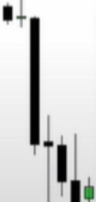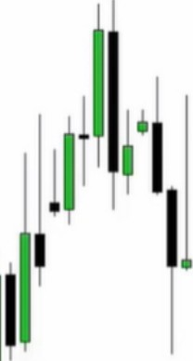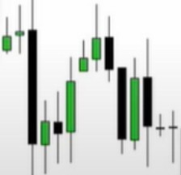

**Seti Stops**

A liquidity pool

Everything you see on 1 timeframe happens on other timeframes as well, its fractal If we anticipate a move higher, first thing is

Where can it go to?

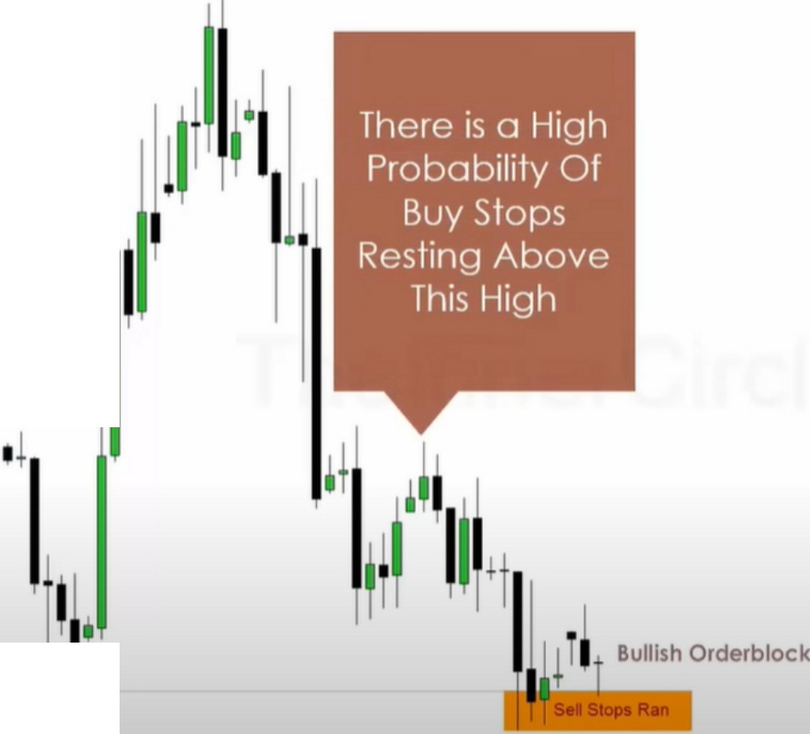

**Sel Stops**



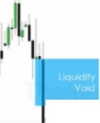}I,,

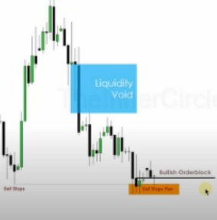

r I.

. **1 *l***

1,,.1 **'l/11**.,**1**,I

**Buy Side Liquidity**

·1.,J

**1/lll**

...

If they take sell stops theyre probably accumulating buy orders and if we have suggestions in price action in the form of liquidity void and buy stops, we may have a high probability of going long

**i**I**li**-**iiiiiiii**-

1. 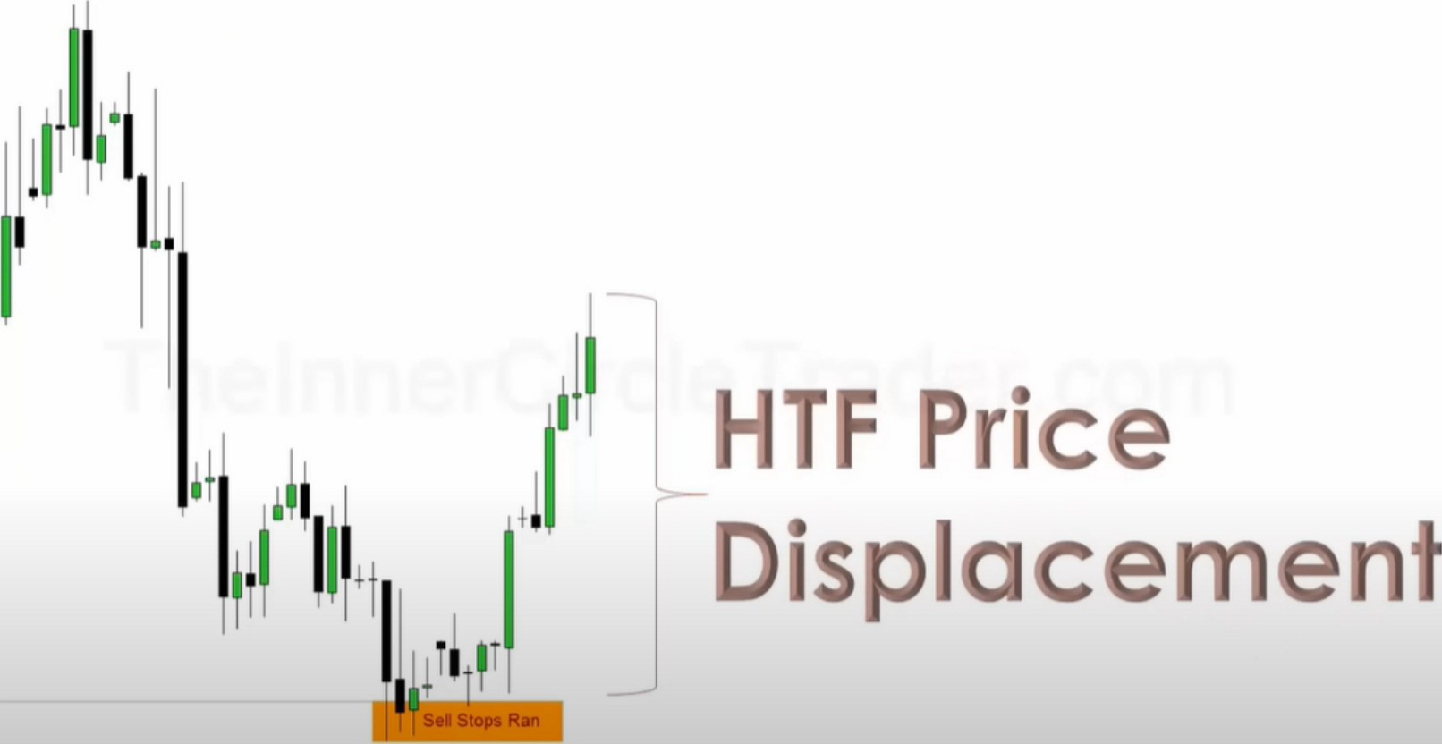**HTF** displacement

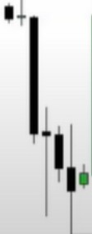

Daily charts are not going to move this dynamic without institutional sponsorship



**Sel Stops**

1. Where did it start?

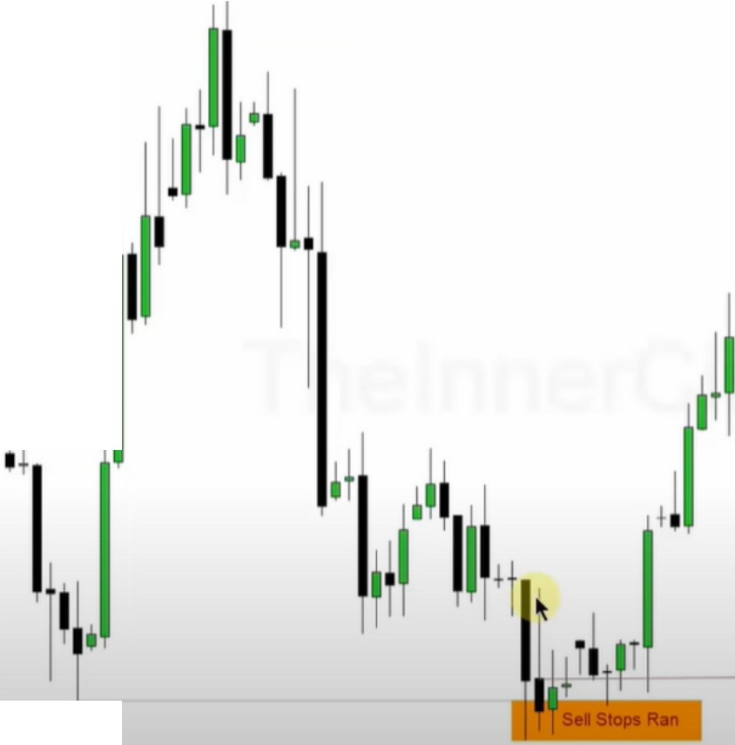

**Sell Stops**

The orderblock, if price wants to come down we can look to buy there

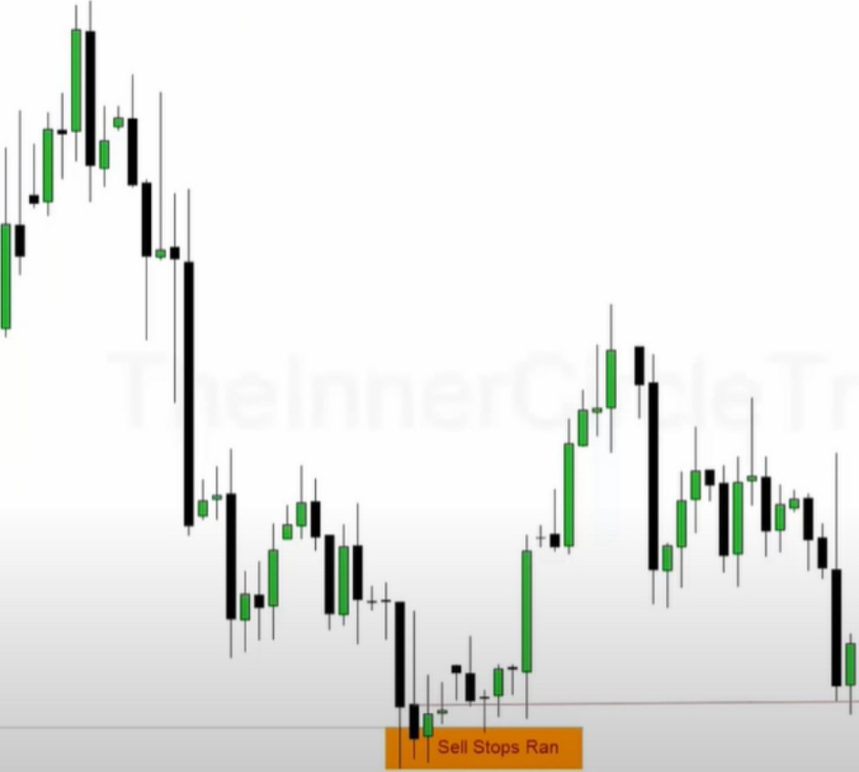To identify institutional sponsorship in a particular segment of price action you NEED to see immediate dynamic response. If its lethargic and not willing to move right away that means theres no institutional orders in that area. So if you see that when youre in a trade either reduce risk or just cut the trade completely. Don't marry the idea. If youre on the right side, price will move dynamic immediately.

'

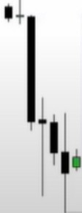

**Sen Stops**

We got 1 and 2 of the criteria now, HTF displacement and price traded back into a discount

1. Where is the short term buy liquidity? Where can institutions sell their orders to willing buyers

11d1

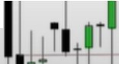I !

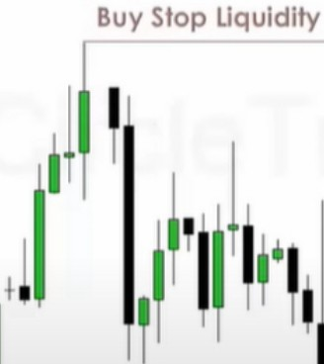

'I'I·

**Sell Stops**

111

II11!

11!I

**01!iiii**

*,_*

**Bullish Orderblock**

And if theyre willing to hold to this one, what will be the next likely target?

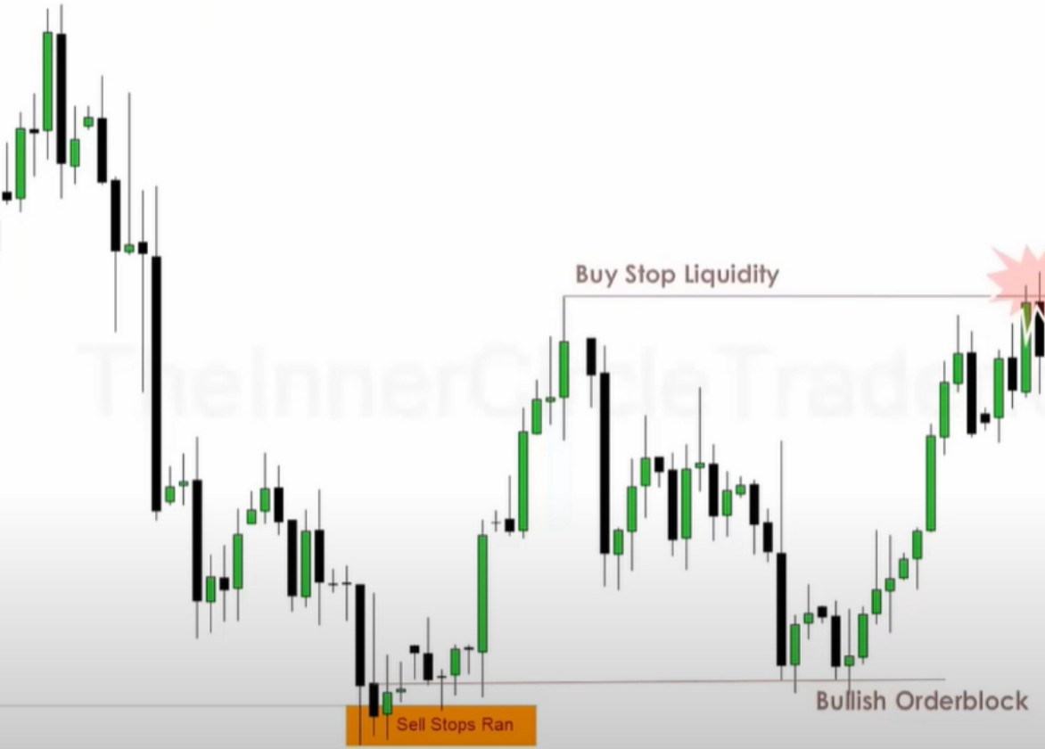Once we hit that, what is price doing? Its pairing orders with buy stops, so whats the next institutional orderflow suggestion? The next high

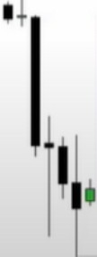

**Sell Stops**

Buy Slop Liquidity

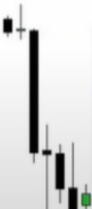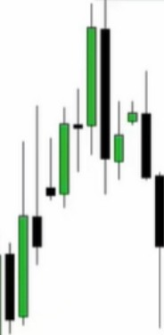

If it wants to go up there, that means its highly unlikely for price to go all the way back down to the bullish orderblock again. Because market structure now shifted when we went above that high and institutions already bought the first time at the orderblock

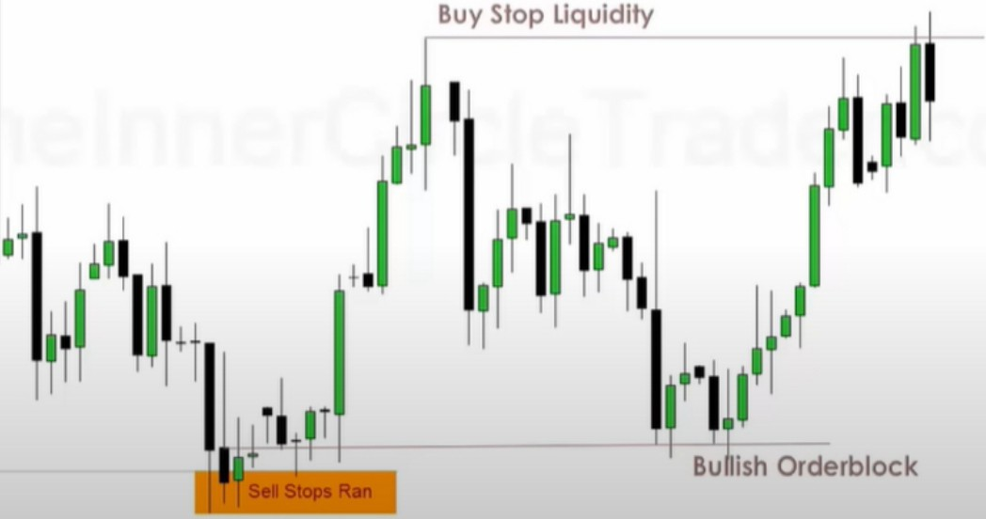

**Sel Stops**

First buying - EQ/midway point - 75% - And then ultimately terminus above the high 4 stages of a price swing

Institutional should support price at these levels

At the start they usually move fast so you can't get involved, then at EQ youll likely get another chance, so EQ of the target range

**Buy Slop Liquidity**

11 1

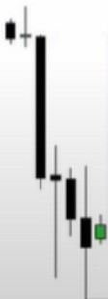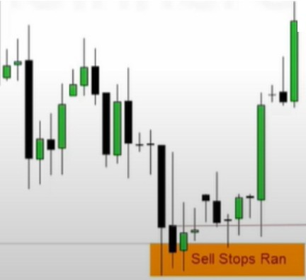

**Buy Slop Liquidity**

! **1**

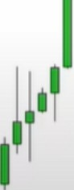11 j **1 1,11,**



**BuLh Orderblock**

**Sel Stops**

So institutional sponsorship should protect that downclosed candle until we get to the buy stops

Each time we take out buy stops we dont collapse the trade, we dont look for reversal, we look for willingness to keep going higher to take all the buy stops

Buy Slop Liquidity

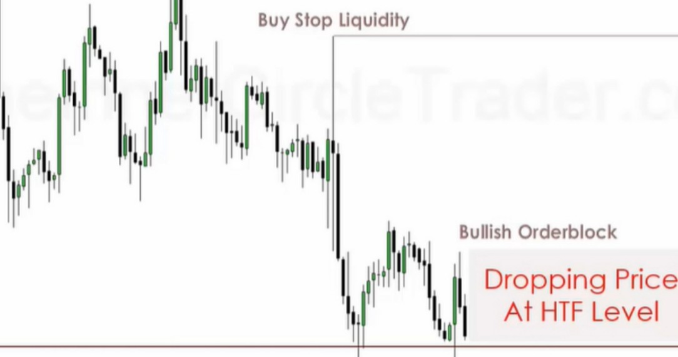

**11**

ml'1,11 *lw�*

Buy Slop Liquidity

**111**

1

1

l11II

ICT 'vlol"'t>ly 'vlel"'orsn p - t.JoverT'b **20 6** - ICT Teoc. ng 3 o! -S

Buy Slop Liquidity

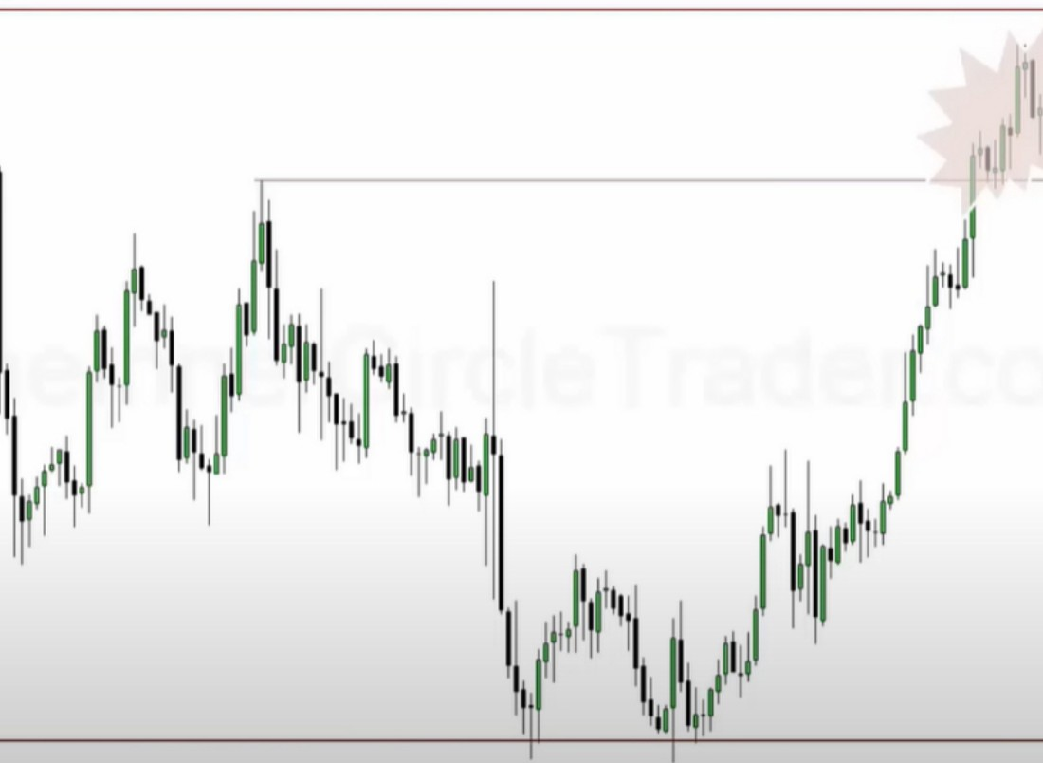

**!11**

i11l'1,1I l,1iil1

/1f

It



As price surges higher, runs trough. While it was a dynamic surge trough that second level of liquidity, it fails to go back to that old high, this is classic price action.

We're not seeing them letting price go lower, so thats a sign of institutional sponsorship

t· o

. 1o

al

t· po

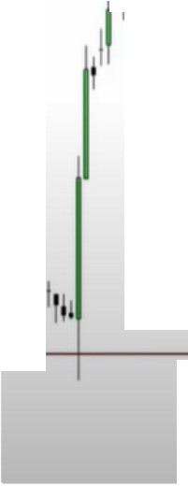

''1/

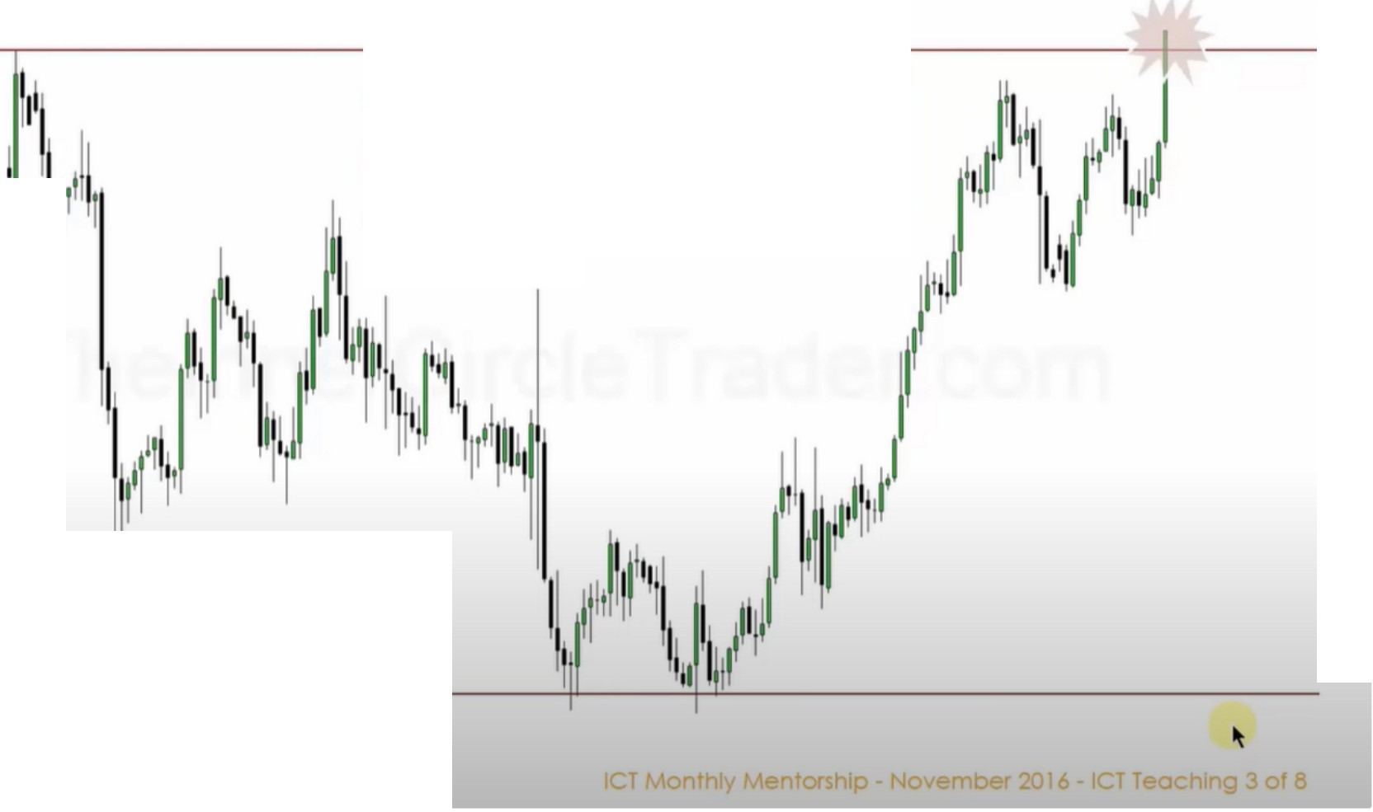

The lnstitu

et's Take A Cl

n1 This PriceA c ion ..n. sorship

n

sser Look At

1 11 j

1111

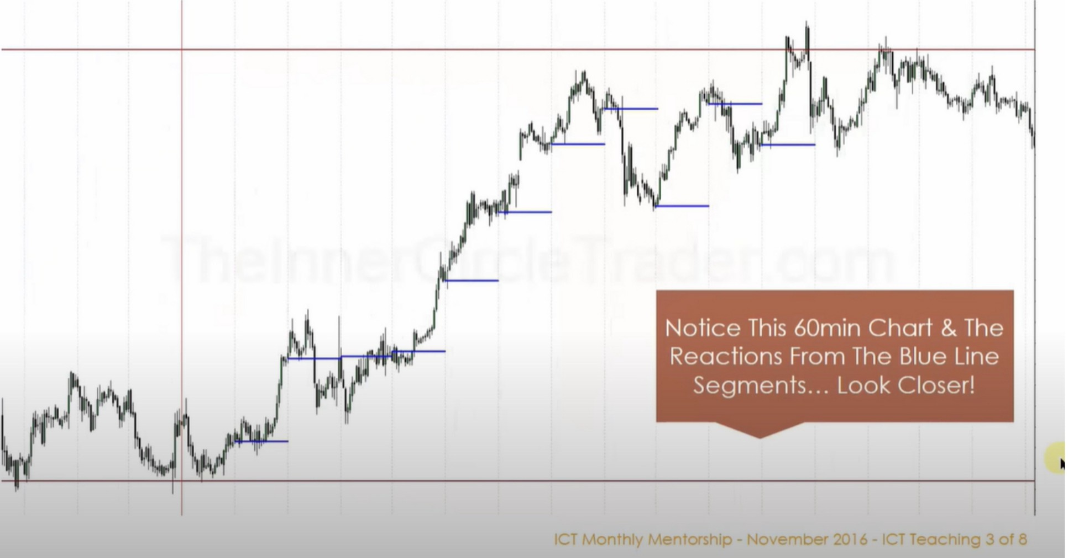

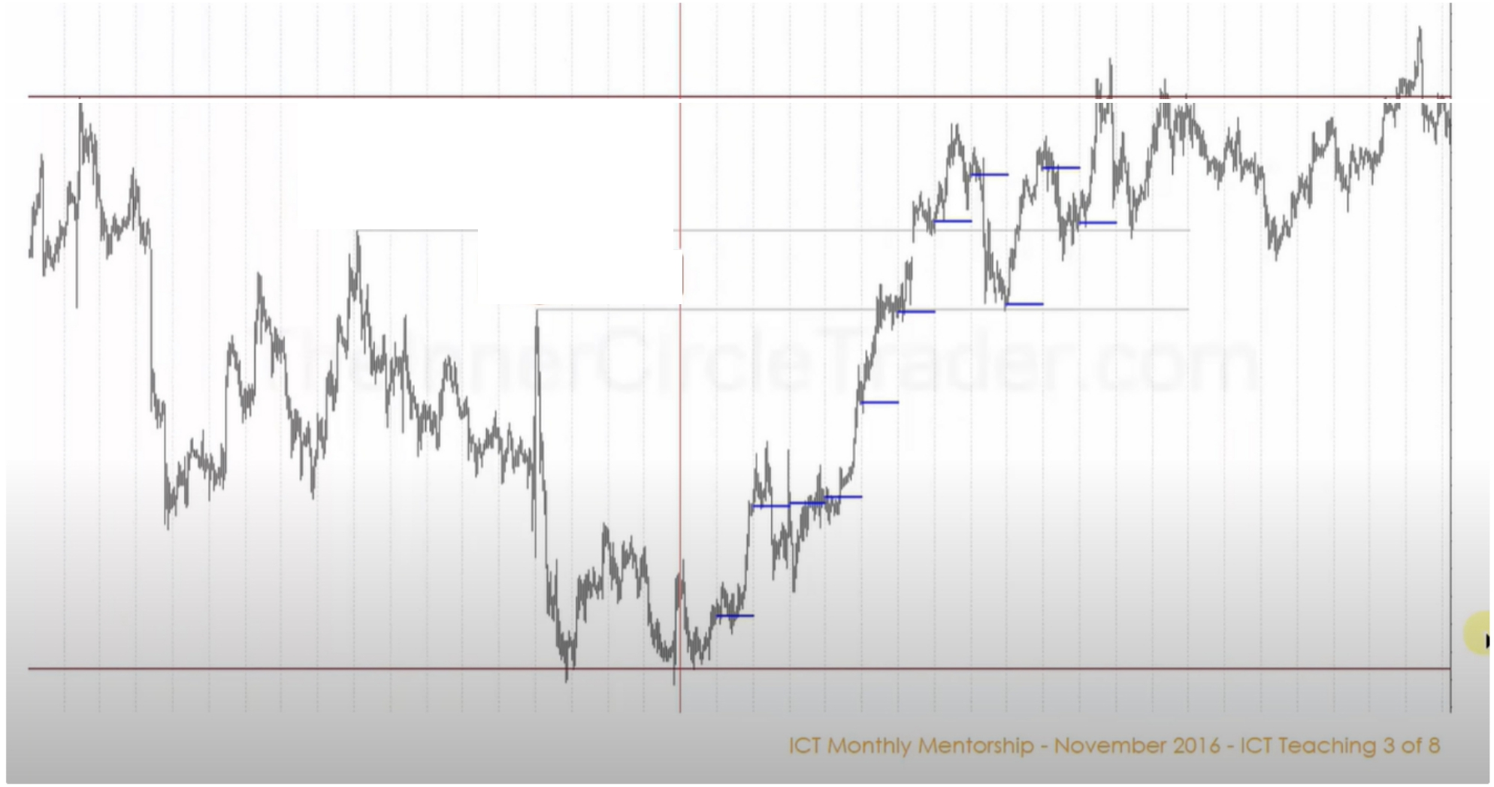

Old High

Old High

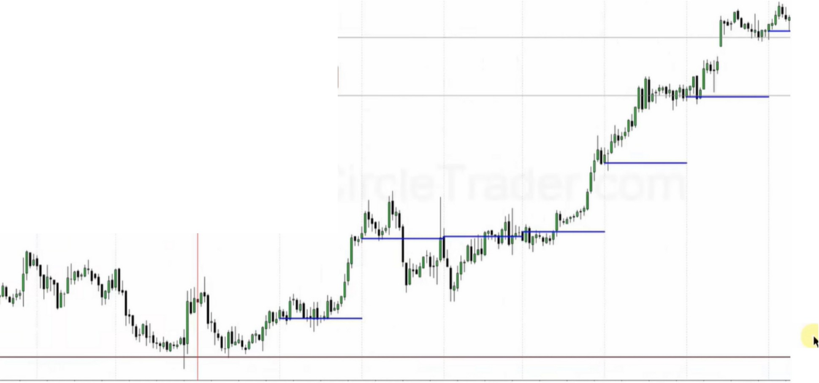

Old High

Old High

CT Mont'1Iy Mero+orsh p - "Jovernber 2016 - CT Teocrlng 3 of 8

The blue lines are midnight open New York

If we suspect price will be bullish, what well see in the form of institutional sponsorship, price below the MNO line should be accumulated

If were bullish we dont care what price does above the MNO, only below it and where does it reach for below it, a liquidity void? Orderblock?

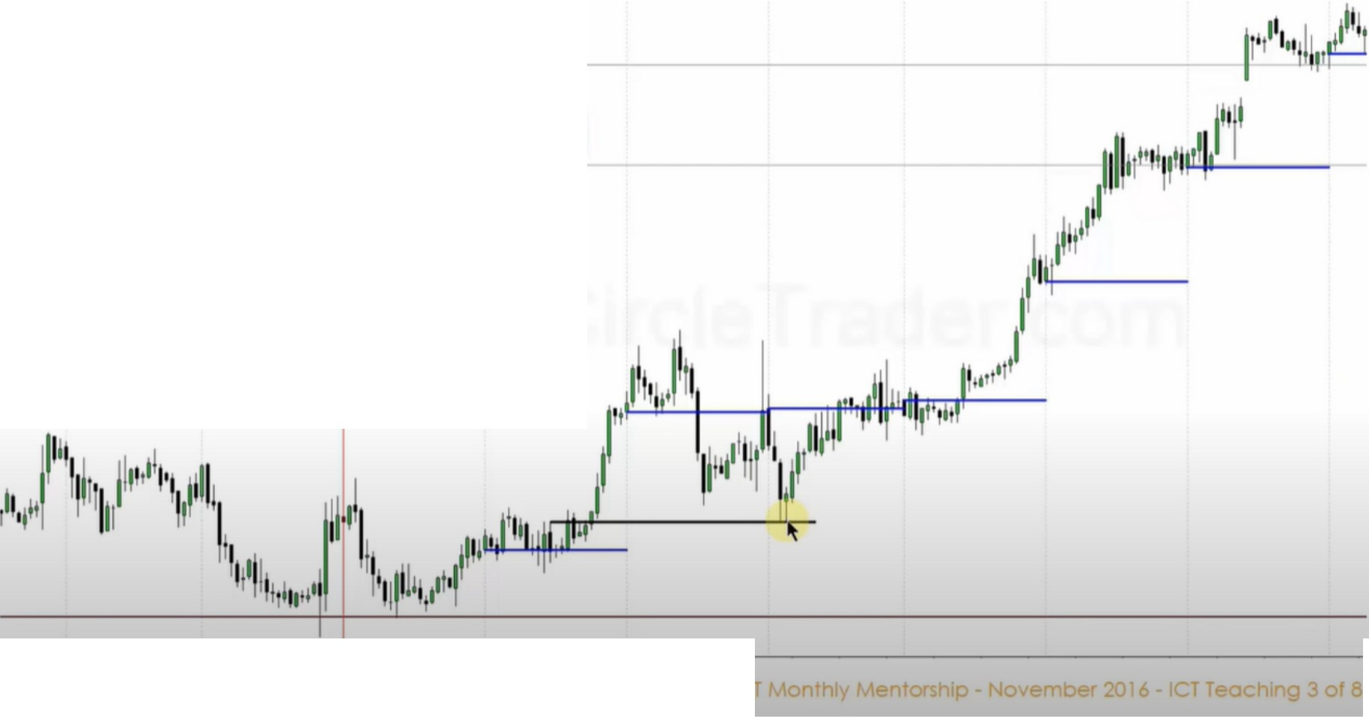

Old High

Old High

When we find the opening price, were going to be looking for a downcandle, it should be a capitilization of new longs. We see that come to fruition when the downcandle is violated.

So when a downcandle forms, a candle trades trough it on the upside, at a later time when we come back to it we can buy at it, and the buying has to be below the opening price of that day That can happen during london or new york doesnt matter

When were at an EQ of a range we want to see an orderblock to see a justification of wanting to go higher to expand away from EQ

Using downcandle from previous days is okay

Power of 3, buy near the opening and exit at the close Sounds easy, but this is how you do it

Look at what happens at the old high, its consolidating trapping support and resistance traders to then expand to the upside

Right before the terminus it stops, getting everyone excited that it will go lower, tricking everyone. It will retrace back to an old high, thats when support and resistance does work, because it has an unfullfilled objective to the upside

These old orderblocks are forming at certain times Which orderblock should you use?

It starts with where the market should go, that starts what we looked at in september All these ideas start to begin to take shape

Every orderblock used here is linked to a london session or new york session, and theyre happening from the previous day or a couple days ago, and they should be capitilized on again because there is an underlying interest for the market maker to see price go higher so theyre not going to let price retrace far, but if it retraces it will retrace bacnk into logical areas, in the form of a bullish orderblock or running an old low. Lows can also be previous london or new york sessions low, theyll take out the SSL and then rally up, same thing for orderblocks you want to be focusing on the london session and new york session and use those downcandles from previous sessions to

give you new buying opportunities

If youre seeing this come to fruition in the charts, youre seeing and identifying institutional sponsorship. EVery successful! trade will have these marks.

When you have this it will be clear and you wont be freaked out when it retraces

Focus on specific orderblocks that take place at london and new york, they will help you discern wether there is institutional sponsorship in your trade, if you see the lack of that chances are you're porbably offside and just wait on the sidelines or reduce risk